**Effects of UA on Survival Rate and Cholesterol Efflux Rate of RAW264.7 Macrophage-derived Foam Cells**

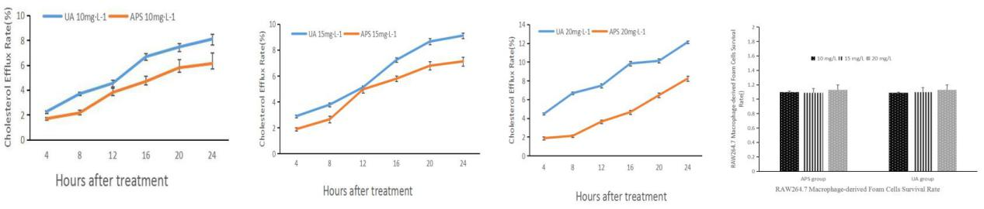

**Fig.1 Effects of UA on Survival Rate and Cholesterol Efflux Rate of RAW264.7 Macrophage-derived Foam Cells** (A) Comparison of the outflows of cholesterol in the UA 10

|  |  |  |
| --- | --- | --- |
| Time | UA 10mg·L-1 | APS 10mg·L-1 |
| 4h | 2.12±0.07 | 1.76±0.05 |
| 8h | 3.87±0.12 | 2.02±0.12 |
| 12h | 4.34±0.26 | 3.43±0.24 |
| 16h | 6.42±0.32 | 4.24±0.37 |
| 20h | 7.23±0.36 | 5.26±0.32 |
| 24h | 7.89±0.67 | 5.78±0.58 |

**Table 1. 10 mg·L-1 UA groupand APS groupCholesterol Efflux Rate**

|  |  |  |
| --- | --- | --- |
| Time | UA 15mg·L-1 | APS 15mg·L-1 |
| 4h | 2.52±0.07 | 1.89±0.05 |
| 8h | 3.21±0.12 | 2.24±0.12 |
| 12h | 5.23±0.26 | 4.23±0.24 |
| 16h | 7.56±0.32 | 5.24±0.37 |
| 20h | 8.36±0.36 | 5.86±0.32 |
| 24h | 9.34±0.67 | 6.32±0.58 |

**Table 2. 15 mg·L-1 UA groupand APS groupCholesterol Efflux Rate**

|  |  |  |
| --- | --- | --- |
| Time | UA 20mg·L-1 | APS 20mg·L-1 |
| 4h | 4.46±0.11 | 1.87±0.16 |
| 8h | 6.67±0.13 | 2.12±0.14 |
| 12h | 7.47±0.21 | 3.64±0.19 |
| 16h | 9.84±0.26 | 4.65±0.21 |
| 20h | 10.12±0.21 | 6.46±0.23 |
| 24h | 12.13±0.15 | 8.24±0.27 |

**Table 3. 20 mg·L-1 UA groupand APS groupCholesterol Efflux Rate**

|  |  |  |  |
| --- | --- | --- | --- |
|  | 10 mg/L | 15 mg/L | 20 mg/L |
| APS group | 1.1±0.03 | 1.09±0.09 | 1.13±0.02 |
| UA group | 1.09±0.01 | 1.1±0.06 | 1.13±0.07 |

**Table 4. UA groupand APS group Cell survival rate**

**Effect of UA and APS on Foam Cell Formation** 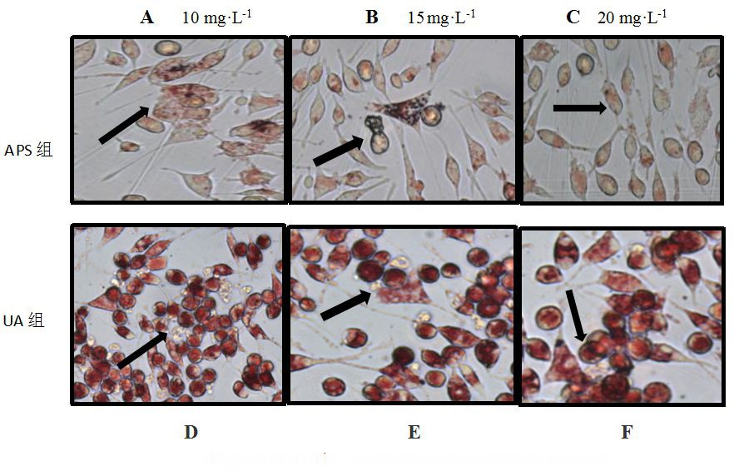

**Fig.1 Effect of UA and APS on Foam Cell Formation**

**Effect of ursolic acid (UA) and astragalus polysaccharides (APS) on the gene expression of SIRT1, PPARγ, NCoR and SMRT in macrophage-derived foam cells**

**A 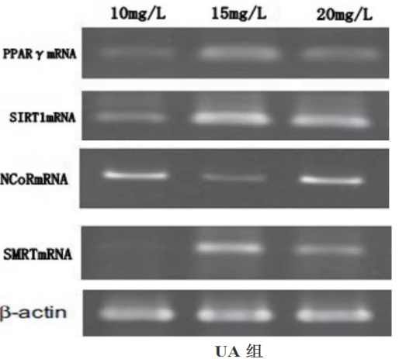 B**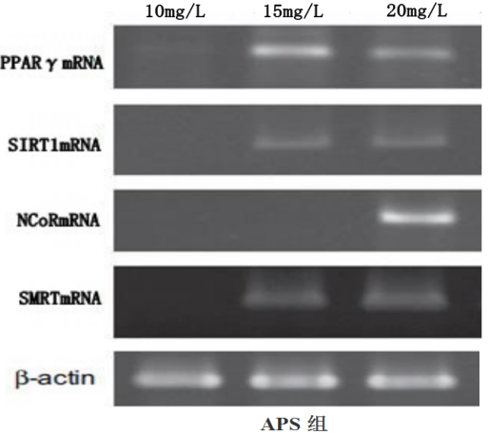

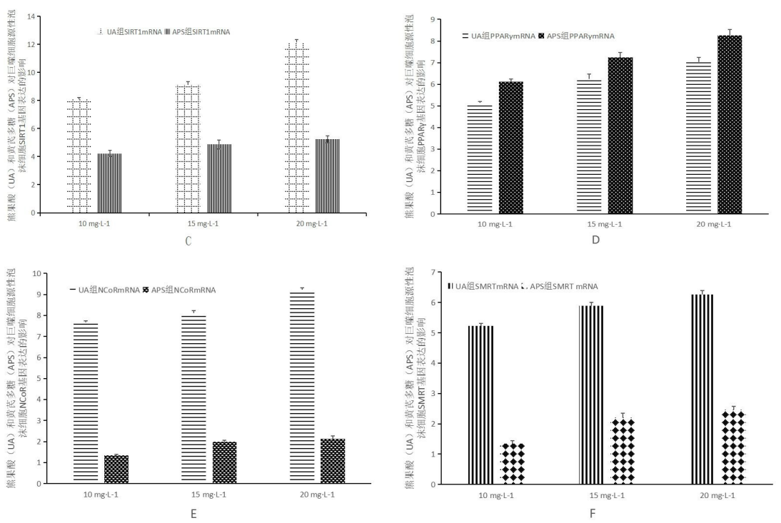

Fig.3 **Effect of ursolic acid (UA) and astragalus polysaccharides (APS) on the gene expression of SIRT1, PPARγ, NCoR and SMRT in macrophage-derived foam cells**

**Table 5.Comparison of Ursolic Acid and Astragalus Polysacharin on the expression of SIRT1mRNA in foam cells**

|  |  |  |
| --- | --- | --- |
|  | UA group SIRT1mRNA | APS group  SIRT1mRNA |
| 10 mg·L-1 | 8.09±0.12 | 4.23±0.23 |
| 15 mg·L-1 | 9.11±0.24 | 4.87±0.32 |
| 20 mg·L-1 | 12.13±0.22 | 5.24±0.25 |

**Table 6.Comparison of Ursolic Acid and Astragalus Polysacharin on the expression of PPARγmRNA in foam cells**

|  |  |  |
| --- | --- | --- |
|  | UA group  PPARγmRNA | APS group  PPARγmRNA |
| 10 mg·L-1 | 5.14±0.07 | 6.12±0.12 |
| 15 mg·L-1 | 6.25±0.23 | 7.24±0.24 |
| 20 mg·L-1 | 7.03±0.21 | 8.26±0.27 |

**Table 7.Comparison of Ursolic Acid and Astragalus Polysacharin on the expression of NCoRmRNA in foam cells**

|  |  |  |
| --- | --- | --- |
|  | UA group  NCoRmRNA | APS group  NCoRmRNA |
| 10 mg·L-1 | 7.68±0.07 | 1.34±0.05 |
| 15 mg·L-1 | 8.12±0.12 | 1.98±0.09 |
| 20 mg·L-1 | 9.23±0.09 | 2.12±0.15 |

**Table 8.Comparison of Ursolic Acid and Astragalus Polysacharin on the expression of NCoRmRNA in foam cells**

|  |  |  |
| --- | --- | --- |
|  | UA group  SMRTmRNA | APS group  SMRT mRNA |
| 10 mg·L-1 | 5.23±0.08 | 1.35±0.09 |
| 15 mg·L-1 | 5.89±0.11 | 2.21±0.13 |
| 20 mg·L-1 | 6.26±0.13 | 2.46±0.11 |

**Effect of ursolic acid (UA) and astragalus polysaccharides (APS) on the protein expressions of SIRT1, PPARγ, NCoR and SMRT in macrophage-derived foam cells**

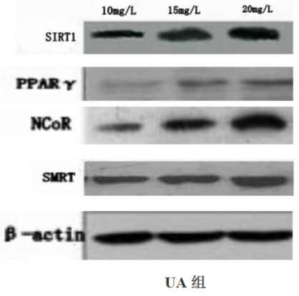 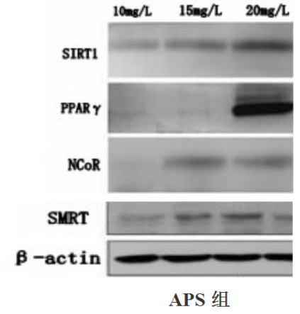

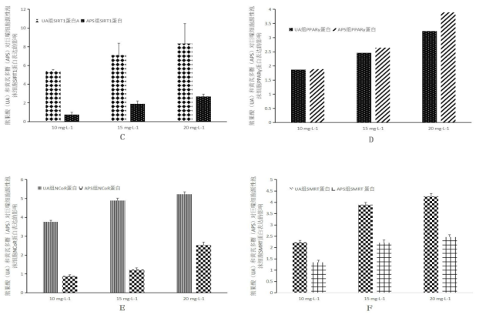

**Fig.4 Effect of ursolic acid (UA) and astragalus polysaccharides (APS) on the protein expressions of SIRT1, PPARγ, NCoR and SMRT in macrophage-derived foam cells**

**Table 9.Effects of Ursolic Acid (UA) on the Expression of SIRT1Proteins in Macrophage-derived Foam Cells**

|  |  |  |
| --- | --- | --- |
|  | UA group SIRT1protein | APS group SIRT1protein |
| 10 mg·L-1 | 5.45±0.12 | 0.76±0.23 |
| 15 mg·L-1 | 7.12±1.24 | 1.89±0.32 |
| 20 mg·L-1 | 8.35±2.12 | 2.68±0.25 |

**Table 10.Effects of Ursolic Acid (UA) on the Expression of PPARγProteins in Macrophage-derived Foam Cells**

|  |  |  |
| --- | --- | --- |
|  | UA group  PPARγprotein | APS group  PPARγprotein |
| 10 mg·L-1 | 1.87±0.07 | 1.89±0.09 |
| 15 mg·L-1 | 2.46±0.45 | 2.65±0.67 |
| 20 mg·L-1 | 3.23±0.65 | 3.89±0.54 |

**Table 11.Effects of Ursolic Acid (UA) on the Expression of NCoR Proteins in Macrophage-derived Foam Cells**

|  |  |  |
| --- | --- | --- |
|  | UA group  NCoR protein | APS group  NCoRprotein |
| 10 mg·L-1 | 3.76±0.08 | 0.89±0.07 |
| 15 mg·L-1 | 4.89±0.13 | 1.23±0.09 |
| 20 mg·L-1 | 5.23±0.12 | 2.54±0.15 |

**Nov.12 ,2017**